*Americana fleet managemenT and Telematics*

Business Case

|  |  |
| --- | --- |
| Business Case | |
| Project Title | *ALMP Fleet management and Telematics* |
| Project Sponsor | Ramandeep Singh Virdi |
| Project Manager: | Arman Singh |
| Technical Manager: | Vinod Kumar Tiwari |
| Project Owner: | Dheeraj Pant |

**Document Control**

|  |  |  |  |  |  |
| --- | --- | --- | --- | --- | --- |
| Version No. | Date | Author | Change History | Reviewed By | Approved By |
|  |  |  |  |  |  |
| V 0.0.1 | 12-10-2023 | Vinod Kumar Tiwari |  |  |  |

Contents

ExECUTIVE SUMMARY 4

PROJECT DESCRIPTION 4

Delivery Cost and Budget 5

Savings and fleet compliance 6

• Improved safety and compliance 8

• Reduced fuel costs 8

• Lower overall operational costs 8

• Increased productivity 8

• Better communication 8

Assumptions 8

# ExECUTIVE SUMMARY

Telemetry IoT integration with ALMP provides end-to-end control and transparency for fuel consumption, fleet optimization, maintenance costs and safety.

This innovative fleet management solution optimizes driver and vehicle utilization through real-time data tracking, achieving increased productivity and cost reduction.

Key business goals as below:

* Expense & fuel management system
* off shift & On shift fleet tracking
* Driver & Vehicle wise fleet efficiency Monitoring
* Fleet wise Productivity (Utilization vs expenses)
* Complaint management system

Following is the projection for next year the spending, savings, and net cost savings:

# PROJECT DESCRIPTION

ALMP with an integration approach and fleet management will be helping in reduction of the run cost for drivers and vehicles with Americana Last Mile Platform product to achieve more efficient utilization of riders and vehicles to optimize journey and order delivery experience.

* Automated Driving Habit Assessment
  + Performance Report
  + Driver Training
  + Prevent unsafe driving.
  + Driver Management
* Crash Alert
  + Over Speed Alarm
  + Accident Alerts
  + SMS Alerts
* Optimize Fleet Delivery Routes with On-trip & off-trip Monitoring.
  + Fleet live tracking
  + Geo fencing
  + Route allocation

# Delivery Cost and Budget

ALMP platform integrated fleet management solution will initially require having smart devices enablement on vehicles available with the drivers to continuous share the data with internal Americana platforms.

|  |  |  |  |
| --- | --- | --- | --- |
| **Cloud Infra and Licenses Cost for IoT Integration with ALMP** | | | |
| **Environments** | **Items** | **Unit Price** | **Expected Cost ($ per year)** |
| **($ per month)** |
| DEV | ALMP CLOUD DEV ENVIRONMENT (CAPEX) | $ 146.44 | $ 1,757.32 |
| QA | ALMP CLOUD QA ENVIRONMENT (CAPEX) | $ 146.44 | $ 1,757.32 |
| UAT | ALMP CLOUD UAT ENVIRONMENT (CAPEX) | $ 292.89 | $ 3,514.63 |
| PROD | ALMP CLOUD PROD ENVIRONENT (OPEX) | $ 2,928.86 | $ 35,146.32 |
| DR | ALMP CLOUD DR ENVIRONMENT (OPEX) | $ 146.44 | $ 1,757.32 |
| Licenses & APIs | Google Maps, Monitoring, Atlassian, Confluent, API etc. (CAPEX+OPEX) | $ 6,000.00 | $ 72,000.00 |
|  |  |  |  |
| **Estimated Total ALMP Infra Cost** | | | **$ 57,966.45** |

With all the spending below will be the cost of delivery of Fleet Management System with ALMP integration scope:

|  |  |
| --- | --- |
| **Estimated Total Cost of Americana Fleet Management** | |
| Estimated Total ALMP Infra Cost (per year) | $ 57,966.45 |
| Estimated Total Rollout Cost | $ 9,500.00 |
| Estimated Total Development Team Cost | $ 40,532.40 |
|  |  |
| **Total Estimated Cost of Delivery (Without Device)** | **$ 107,998.85** |

Note: Market-wise DoD will increase, and the cost of devices will be gradually reduced as this feature will be enabled with the DoD partners.

# Savings and fleet compliance

Additional savings

In addition to above savings further the smart devices with GPS trackers will also help reduce Stolen Bikes with following:

|  |  |  |  |
| --- | --- | --- | --- |
| **Estimated Cost Savings on Vehicles Theft** | | | |
| **S. No.** | **Year of Theft** | **Total Theft** | **Estimated Vehicle Cost** |
|  |
| 1 | FY-21 | 7 | $ 91,000.00 |  |
| 2 | FY-22 | 4 | $ 52,000.00 |  |
| 3 | FY-23 | 3 | $ 39,000.00 |  |
| 4 | FY-24 | 5 | $ 60,666.67 |  |
|  |  |  |  |  |
| **Total Estimated Cost of Theft Vehicles** | | | **$ 242,666.67** |  |

Beyond cost benefits

# Improved safety and compliance

# Reduced fuel costs

# Lower overall operational costs

# Increased productivity

# Better communication

# Assumptions

Below is the list of assumptions made during this draft version of documentation with basic costing, budgeting, and savings can be listed in below:

|  |  |
| --- | --- |
| **Assumption** | **Actions to validate Assumptions** |
| Microsoft Azure Cloud BoQ for Production is considered as **$11,715.44** | Validation can be done with Etisalat. |
| Monthly order volume considered from ALMP LAMDA DB with 18% order volume for 1click in October 2023 | Can be validated with the monthly order volume available in LAMDA DB for Power BI reporting tables. |
| ALMP Dev, QA is considered 5%, UAT 5% and DR 5% of Production BoQ. | Below attached projected ALMP production BoQ component list shared via Etisalat. |
| For savings only considering 53% values to consider in estimates. | Trial case study with a few IoT devices are available above to validate. |

**ALMP Cloud (BoQ) Considered for infrastructure calculation:**

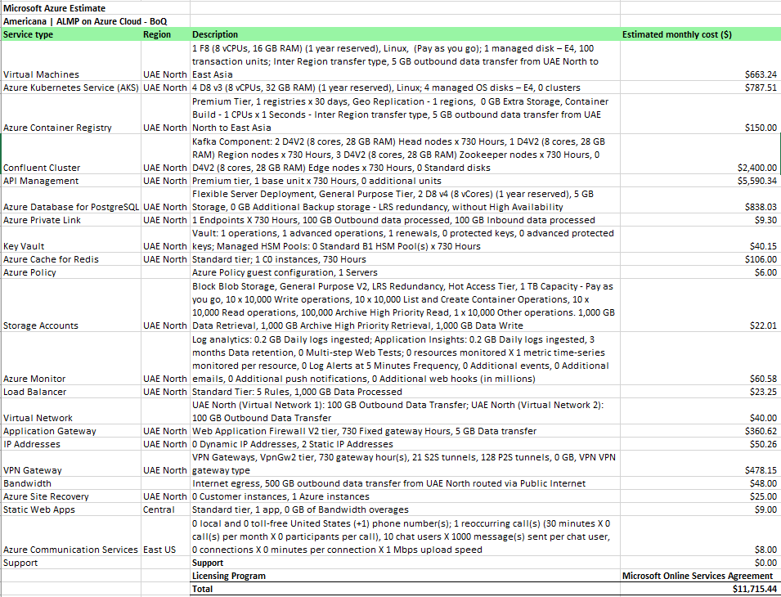

Appendix A: Business Case - Approval

The undersigned acknowledge they have reviewed the ALMP Fleet Management **Business Case** and agree with the approach it presents. Changes to this **Business Case** will be coordinated with and approved by the undersigned or their designated representatives.

|  |  |  |  |
| --- | --- | --- | --- |
| Signature: |  | Date: |  |
| Print Name: |  |  |  |
| Title: |  |  |  |
| Role: |  |  |  |

|  |  |  |  |
| --- | --- | --- | --- |
| Signature: |  | Date: |  |
| Print Name: |  |  |  |
| Title: |  |  |  |
| Role: |  |  |  |

|  |  |  |  |
| --- | --- | --- | --- |
| Signature: |  | Date: |  |
| Print Name: |  |  |  |
| Title: |  |  |  |
| Role: |  |  |  |